**SWAPPING OF NUMBERS**

**EXP NO: 15**

**AIM:** To compute swapping of numbers using 8085 processor.

**ALGORITHM:**

1. Load a 8-bit number from memory location into accumulator.
2. Move value of accumulator into register H.
3. Load a 8-bit number from next memory location into accumulator.
4. Move value of accumulator into register D.
5. Exchange both the registers pairs.
6. Halt

**PROGRAM:**

LDA 2001

MOV B,A

LDA 2002

MOV C,A

STA 2003

MOV A,B

STA 2004

HLT

**OUTPUT:**

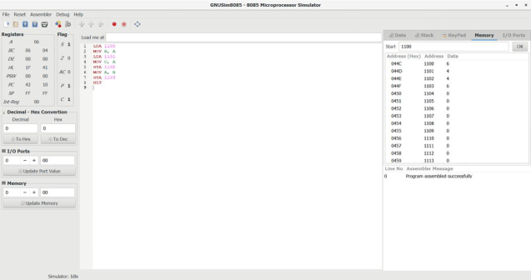

**RESULT:** Thus the program was executed successfully using 8085 processor simulator.